**STAT 40001/MA59800 Statistical Computing Fall 2017**

**Lab -16**

1. In order to find the relationship between the number of hours student study outside the class and their test score we have collected a sample of 10 students and observe their test score and the number of hours they spend outside the classroom.

Student Score # of hours/Week

Andrea 63 3

Ben 79 11

Randy 53 8

Jamie 77 10

Emily 89 13

Darryl 66 5

Joseph 64 4

Eleanor 91 14

Jacob 71 5

Sharon 74 9

1. Calculate the Pearson correlation coefficient.

> score = c(63,79,53,77,89,66,64,91,71,74)

> hour = c(3,11,8,10,13,5,4,14,5,9)

> plot(hour,score)

> data = data.frame(hour,score)

> head(data)

hour score

1 3 63

2 11 79

3 8 53

4 10 77

5 13 89

6 5 66

> cor(hour, score, method = ‘p’) # order does not matter

[1] 0.7989697

1. Calculate the Spearman correlation Coefficient

> cor(hour,score,method = 's')

[1] 0.875384

1. Calculate the Kendall’ s Tau.

> cor(hour,score,method = 'k')

[1] 0.8090398

1. Using each method test the hypothesis that the correlation is nonzero.

> cor.test(hour,score,method='p')$p.value

[1] 0.005561874

> cor.test(hour,score,method='s')$p.value

[1] 0.0009053258

> cor.test(hour,score,method='k')$p.value

[1] 0.001225424

H0: the correlation is zero  
Ha: the correlation is nonzero  
conclusion: reject null hypothesis, the correlation is nonzero.

1. The data frame **Grades** in the **PASWR** package contains the information about the GPA and SAT scores of second semester freshman students.
2. Create a scatterplot of the data to investigate the relationship between gpa and sat scores  
   > attach(Grades)

> plot(sat, gpa)

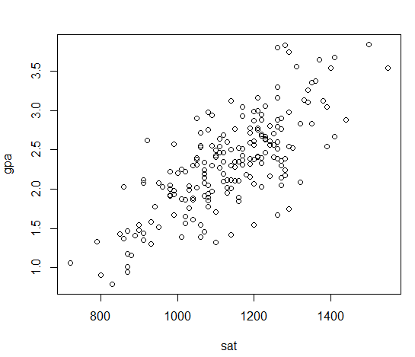

1. Obtain the least squares estimates for  and  . State the estimated regression model.

> model = lm(gpa~sat)

> model

Call:

lm(formula = gpa ~ sat)

Coefficients:

(Intercept) sat

-1.192064 0.003094

Gpa = -1.19 + 0.003049*sat

1. Calculate 90% confidence interval for the regression parameters.

> confint(model,level = 0.9)

5 % 95 %

(Intercept) -1.5596818 -0.82444581

sat 0.0027729 0.00341564